**Task 1: Comparative Research**

The two models we will be evaluating are:

1. **DALL-E 3**: The model developed by OpenAI and integrated into ChatGPT (available for Plus, Team, and Enterprise subscribers).
2. **Imagen 2**: The model developed by Google DeepMind and integrated into the Gemini interface.

Here is a head-to-head comparison based on your specified criteria.

### **Quick Comparison Table**

| Feature | DALL-E 3 (via ChatGPT) | Imagen 2 (via Gemini) |
| --- | --- | --- |
| **Image Quality** | Very high, excels in illustrations and complex scenes. Can look slightly "digitally rendered." | Excellent, a leader in photorealism and clean aesthetics. Images often look like high-quality stock photos. |
| **Prompt Accuracy** | World-class. Its greatest strength is understanding complex, nuanced, and long prompts with multiple subjects and spatial relationships. | Very strong with natural language, but can sometimes simplify or reinterpret highly complex prompts. Captures the "vibe" very well. |
| **Style Flexibility** | Extremely flexible. Can mimic a vast range of artistic styles, from oil painting to pixel art and corporate vectors. | Very flexible, with a notable strength in realistic styles like photography, film stills, and product mockups. |
| **Usability** | **Conversational & Iterative**. You can refine images through conversation ("Now make the hat red"). | **Direct & Fast**. You provide a prompt and get images. Refinement requires editing the prompt and regenerating. |
| **Licensing & Terms** | You own the images you create and can use them commercially. Subject to OpenAI's content policy. | You can use the images you create, including for commercial purposes. Subject to Google's Generative AI terms and policies. |

**Detailed Evaluation**

#### **1. Image Quality**

DALL-E 3:

DALL-E 3 produces high-resolution, intricate images. Its output often has a polished, "digital illustration" feel, even when aiming for photorealism. It's excellent at creating coherent scenes with many interacting elements without them looking distorted or nonsensical. While it can produce realistic images, its default aesthetic often leans more towards hyper-real art than pure photography.

* **Strengths:** Coherent composition, detailed scenes, illustrative quality.

Imagen 2:

Imagen 2's standout feature is its exceptional photorealism. It consistently generates images that are difficult to distinguish from actual photographs. The lighting, textures, and depth of field are often superb. It is particularly skilled at creating realistic human portraits (within its safety guidelines), professional-looking product shots, and convincing nature photography. The images are typically very "clean" with minimal artifacts.

* **Strengths:** Photorealism, realistic lighting and textures, clean and professional look.

**Winner:** **Imagen 2** for raw photorealism. **DALL-E 3** for complex, artistic compositions

#### 

#### 

#### 

#### 

#### 

#### **2. Prompt Accuracy (Prompt Adherence)**

This is a critical distinction between the two.

**DALL-E 3:**

This is arguably DALL-E 3's biggest advantage. Because it is integrated with ChatGPT, your prompt is often expanded and re-interpreted by the language model to be incredibly detailed for the image generator. This allows it to follow very complex instructions with remarkable accuracy.

* **Example Prompt:** "A photorealistic image of a red cube sitting on top of a blue sphere. To the left is a yellow pyramid. The word 'AI' is clearly written on the face of the cube."
* **DALL-E 3 Result:** It is highly likely to get the colors, shapes, spatial relationships (on top of, to the left of), and the text rendering correct. Its ability to generate legible text within images is a major feature.

**Imagen 2:**

Imagen 2 has a strong understanding of natural language prompts but tends to interpret them more holistically. It will capture the essence of the prompt flawlessly but may miss a minor detail in a very complex request. It is generally less reliable than DALL-E 3 for accurately rendering specific text within an image.

* **Example Prompt:** (Same as above)
* **Imagen 2 Result:** It will likely create a beautiful image with the three shapes, but it might place the pyramid on the right, or struggle to render the letters 'AI' correctly on the cube. It prioritizes a high-quality image over 100% literal prompt adherence.

**Winner:** **DALL-E 3** by a significant margin for literal prompt interpretation and text generation.

#### **3. Style Flexibility**

Both models are incredibly versatile, but they have different areas of expertise.

DALL-E 3:

DALL-E 3 has a massive stylistic range. You can ask for anything from "a child's crayon drawing" to "a cyberpunk cityscape in the style of Syd Mead" or "a logo concept for a coffee shop, vector style." It feels very playful and is an excellent tool for graphic designers and artists exploring different aesthetics.

Imagen 2:

Imagen 2 also has a wide range, but its strength lies in styles rooted in reality. It excels at prompts specifying camera types, film stock, and lighting conditions (e.g., "A portrait of a woman, 35mm film photo, golden hour lighting, cinematic"). It's the go-to for creating images that need to look like they were captured by a real camera or designed for a corporate presentation.

**Winner:** **Tie.** DALL-E 3 is better for artistic and illustrative exploration, while Imagen 2 is better for realistic and photographic styles.

#### **4. Usability (User Experience)**

DALL-E 3 (in ChatGPT):

The experience is conversational. This is a game-changer. You can generate an image and then refine it with follow-up commands like:

* "Great, now give me four variations in a 16:9 aspect ratio."
* "I like the third one. Can you make the car in that image blue instead of red?"
* "Change the setting from a city street to a forest."

This iterative workflow makes it very intuitive to hone in on a perfect image.

Imagen 2 (in Gemini):

The experience is more direct and traditional. You write your prompt, and Gemini provides a set of 2-4 images.2 If you want to make a change, you must modify your original text prompt and generate a new set of images. The generation is very fast, but it lacks the back-and-forth refinement capability of the ChatGPT integration.

**Winner:** **DALL-E 3** for its powerful and intuitive conversational editing workflow.

#### **5. Licensing & Terms**

This is a crucial area where both platforms have become more permissive over time.

**DALL-E 3 (OpenAI):**

* **Ownership:** According to OpenAI's Terms of Use, you own the images you create with DALL-E 3.
* **Commercial Use:** You are free to use the images for any purpose, including commercial ones like marketing, book covers, and products.
* **Responsibility:** You are responsible for the content you generate. You cannot create images that violate their content policy (e.g., hate speech, extreme violence, explicit material) and you must not infringe on existing copyrights (e.g., generating an exact replica of Mickey Mouse is not advisable).

**Imagen 2 (Google):**

* **Ownership & Use:** Google's Generative AI Terms of Service allow you to use the generated content for your purposes, including commercial projects.
* **Responsibility:** Similar to OpenAI, you are responsible for your creations. You must adhere to the Prohibited Use Policy. Google is generally seen as more cautious and may refuse to generate a wider range of prompts, especially those involving realistic depictions of specific people.
* **Watermarking:** Google embeds a digital watermark called SynthID into its images, which is invisible to the human eye but can be detected to identify the image as AI-generated.

**Winner:** **Tie.** Both offer full ownership and commercial use rights, which is excellent for creators. The choice may come down to which company's content policy and safety guardrails you prefer.

### **Conclusion: Which One Should You Use?**

* **Choose DALL-E 3 (via ChatGPT) if...** your priority is precise control over complex scenes, you need to include accurate text in your image, or you value an iterative, conversational workflow where you can fine-tune your results. It's the superior tool for detailed storytelling and graphic design.
* **Choose Imagen 2 (via Gemini) if...** your priority is achieving the highest degree of photorealism. It's the best choice for creating stunning, clean images that look like they were taken by a professional photographer, for product mockups, or for when you need a high-quality image quickly from a simple prompt.

**Comparison between two images generated using DALL-E 3 and Imagen 2**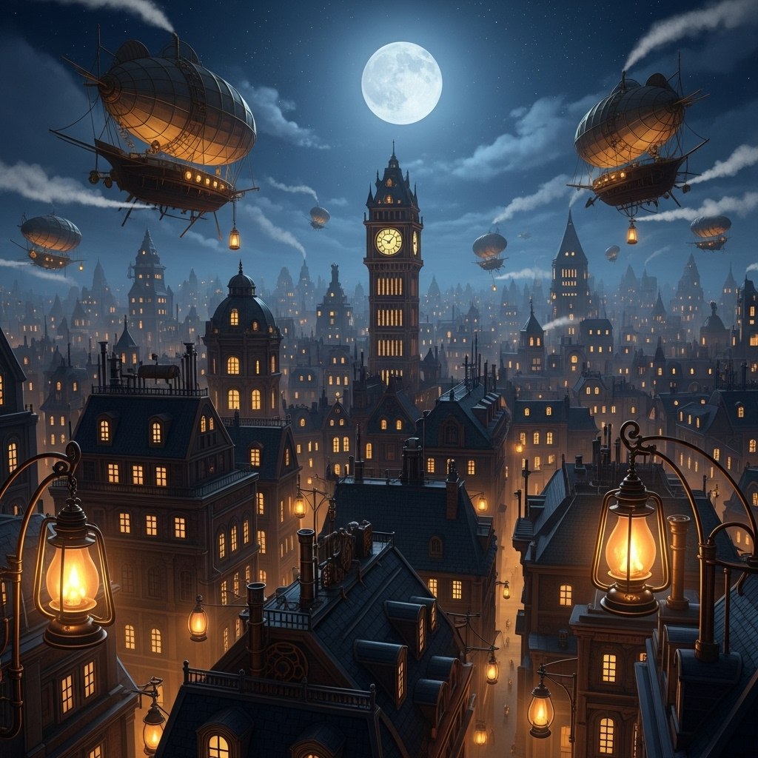

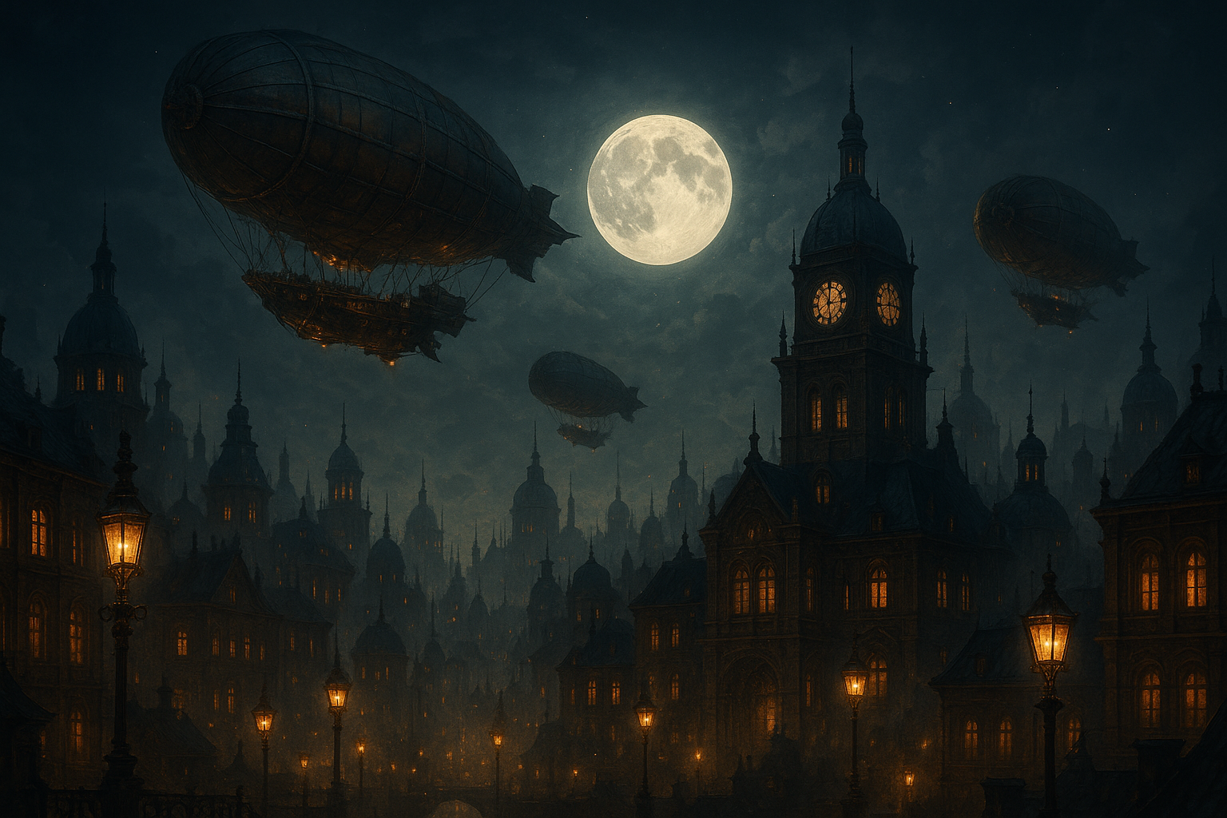

**Imagen 2 DALL-E 3**